# Test Screenshots

**BASE URL (Local server only)**

http://localhost:3000

**1. GET: Fetch All Users**

**Success**

GET /users

**Response:**

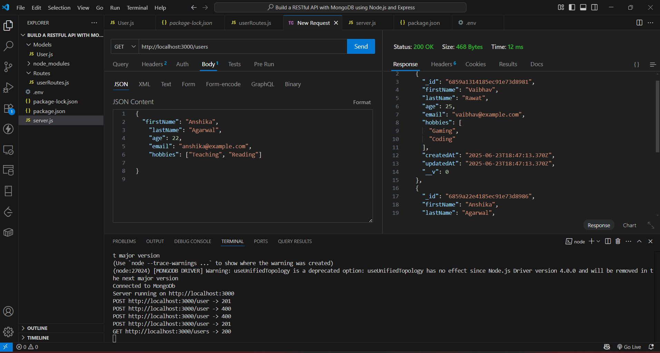

**2. GET: Fetch a User by ID**

**Success**

GET /users/(Monogo Id)

**Response:**

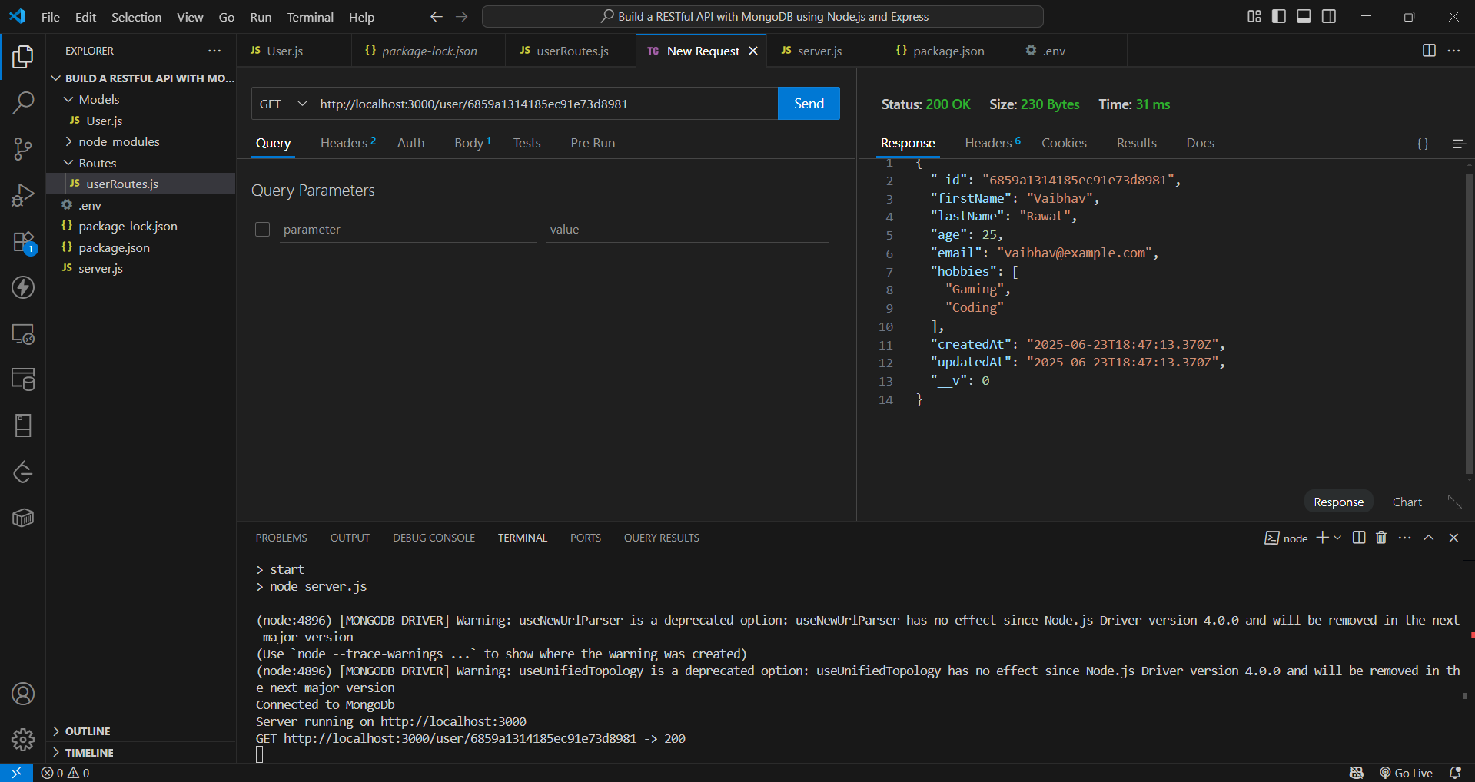

**Error 1: Invalid Object Id Format**

**Request:**

GET /users/123

**Response:**

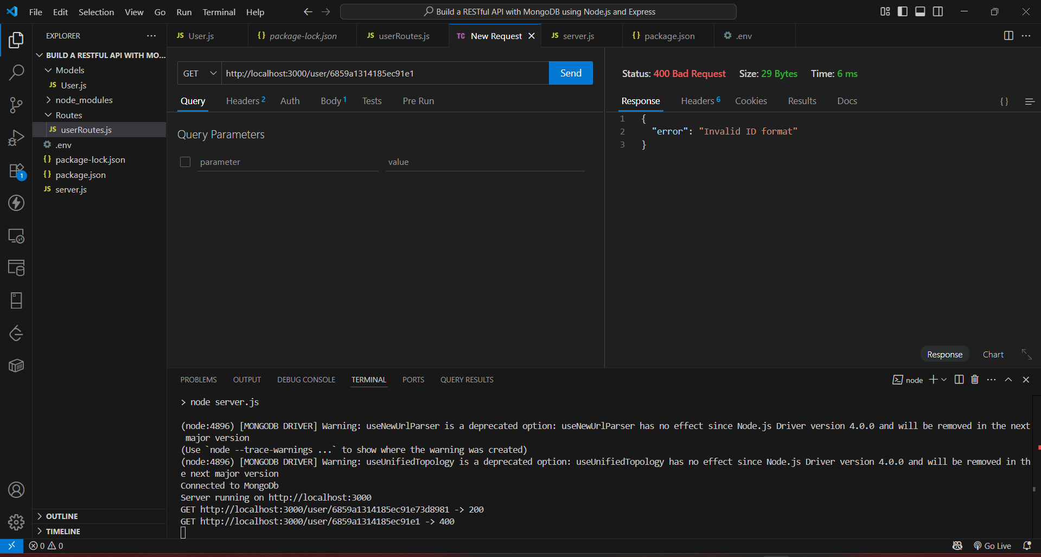

**Error 2: Valid format, but not found**

GET /users/665fc44a3aa1b3a1d7490000

**Response:**

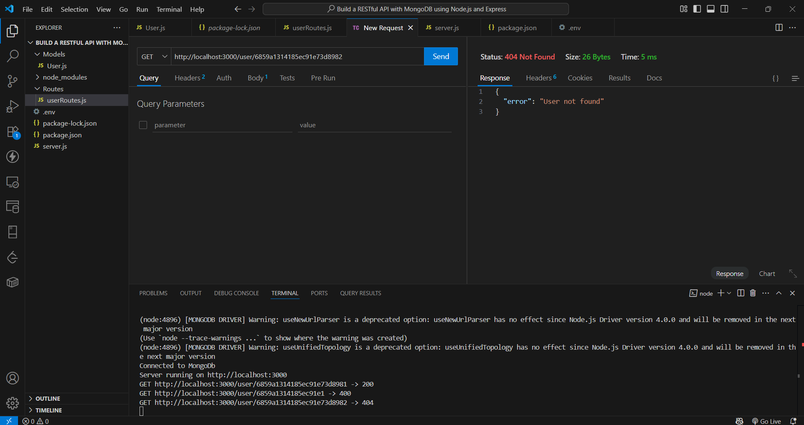

**3. POST: Add a New User**

**Success**

POST /user

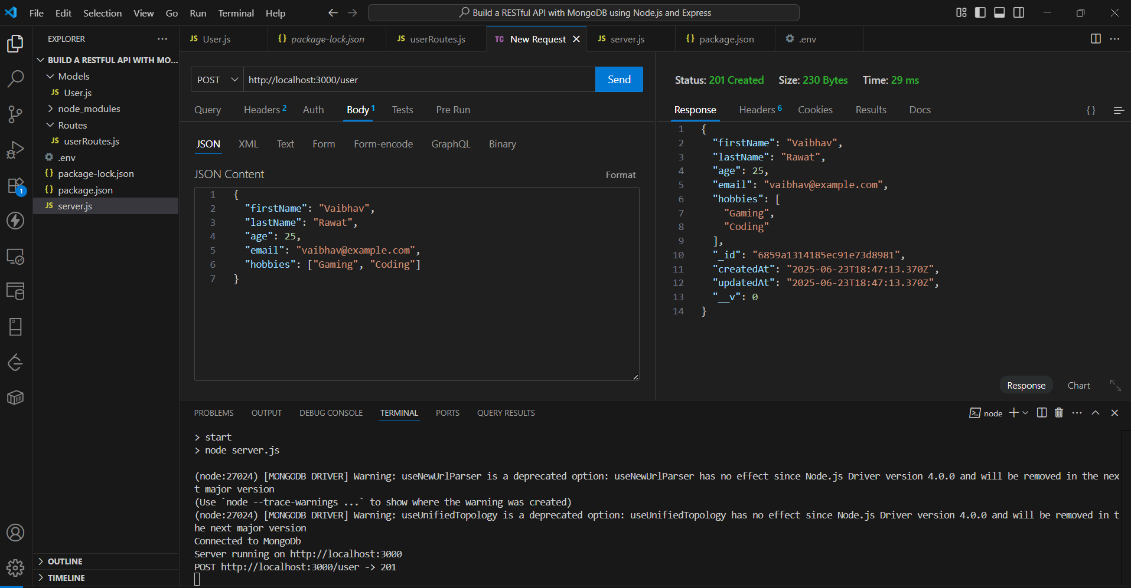

**Error 1: Missing required field**

**Response:**

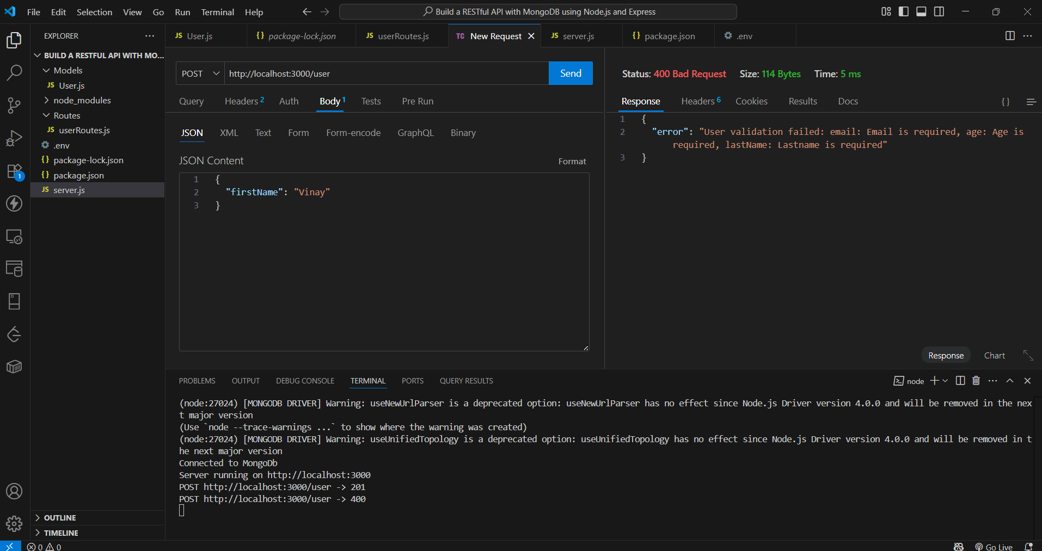

**Error 2: Duplicate email**

**Response:**

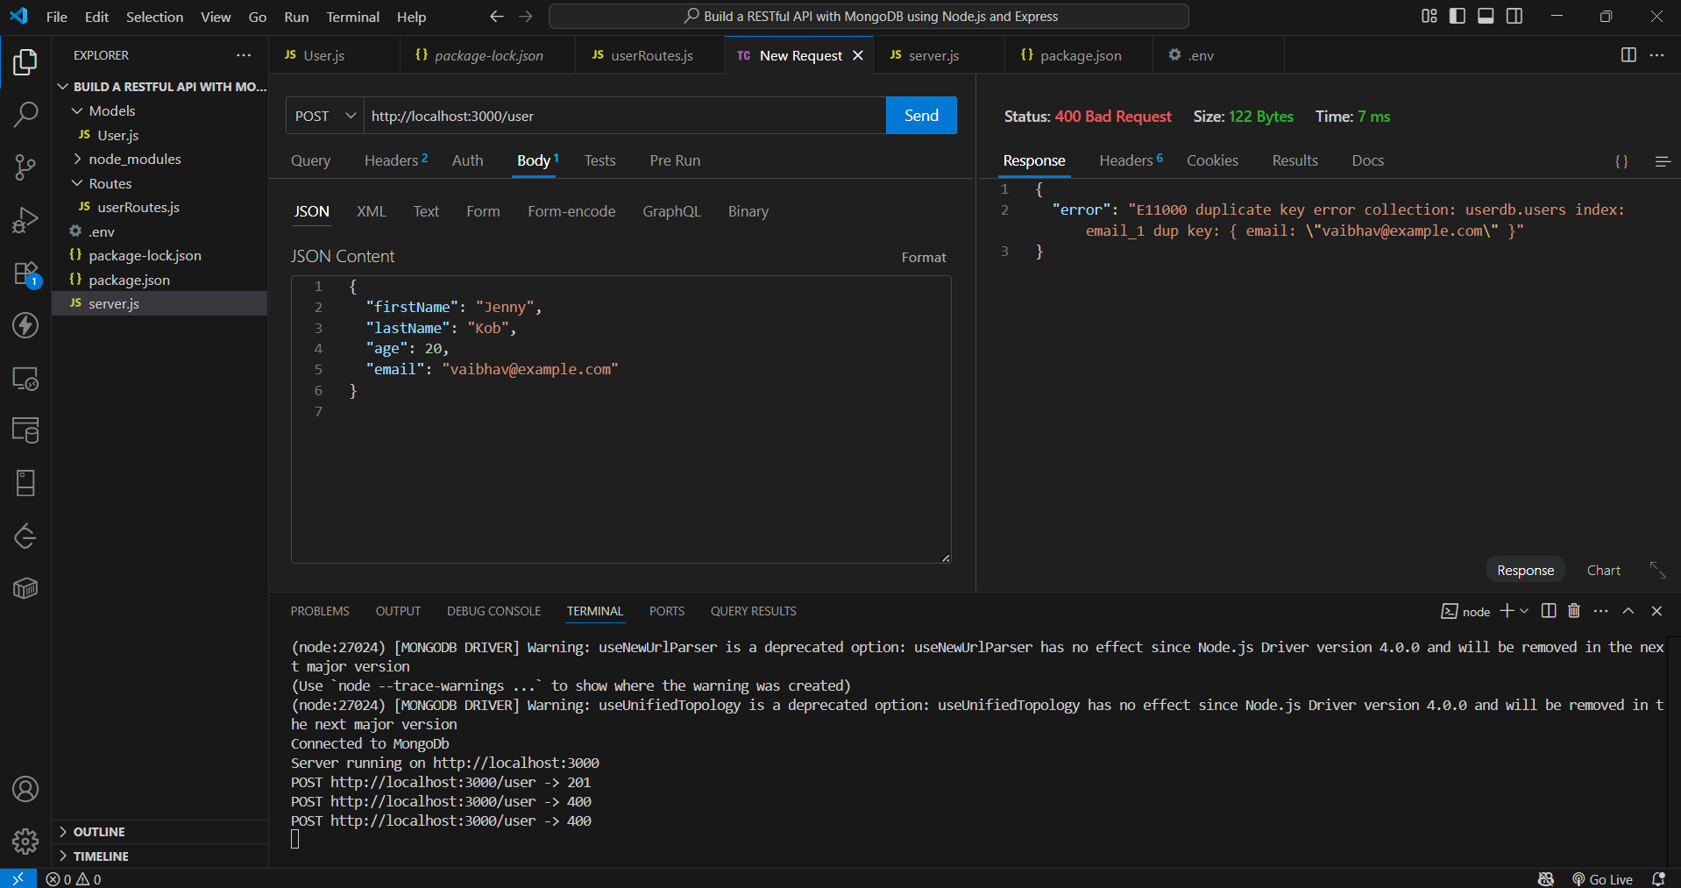

**4. PUT: Update Existing User**

**Success**

PUT /user/mongoId

**Response:**

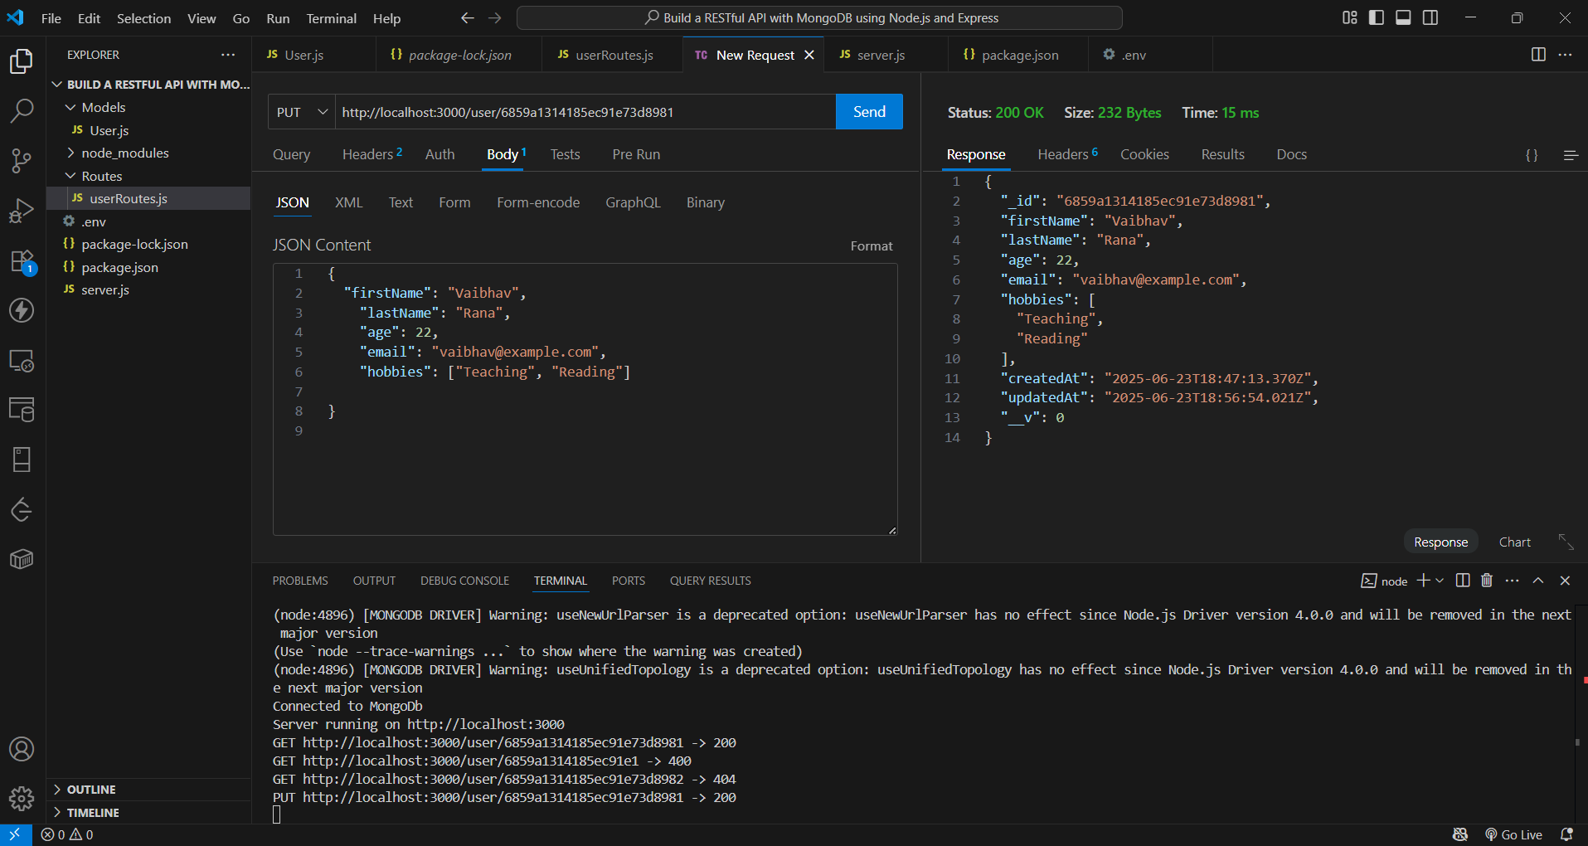

**Error 1: Invalid ID format**

PUT /user/123

**Response:**

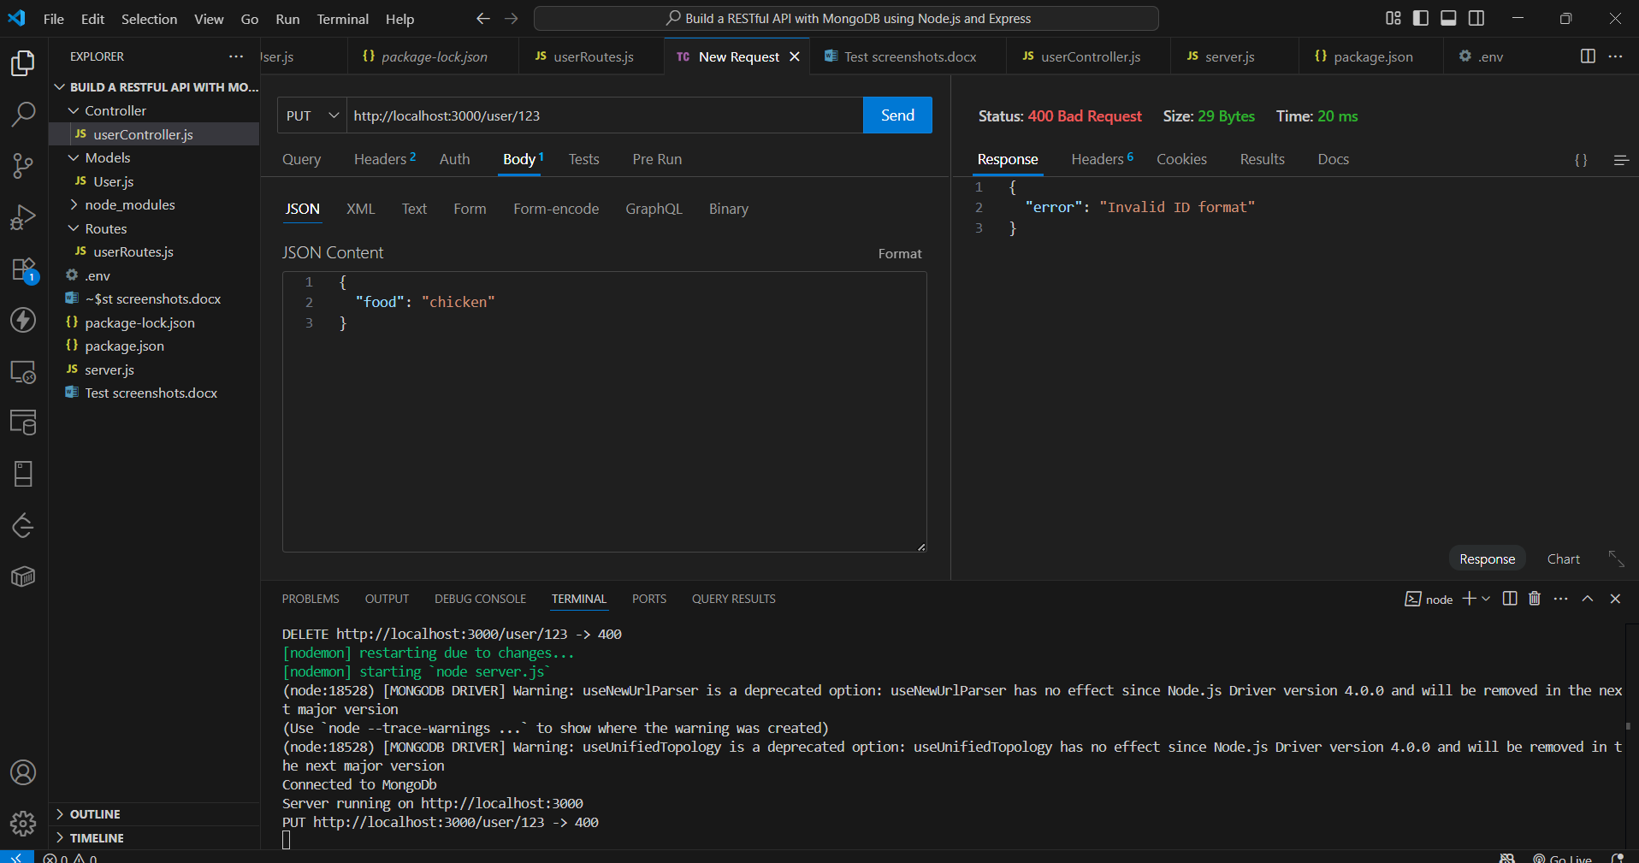

**Error 2: User not found**

PUT /user/665fcabc3aa1b3a1d7490000

**Response:**

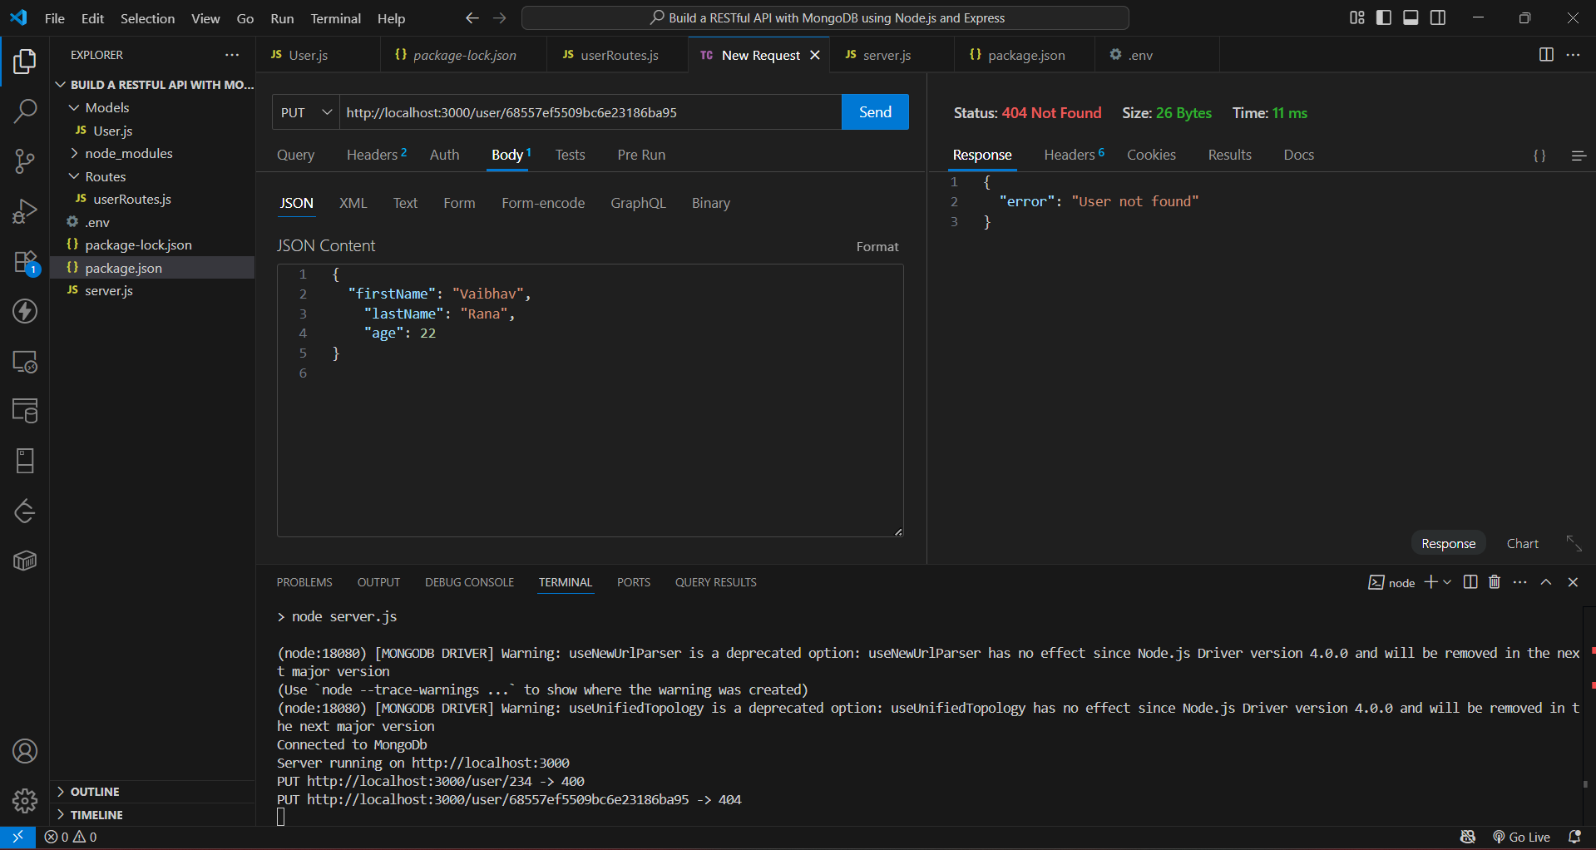

**Error 3: Validation error**

**Response:**

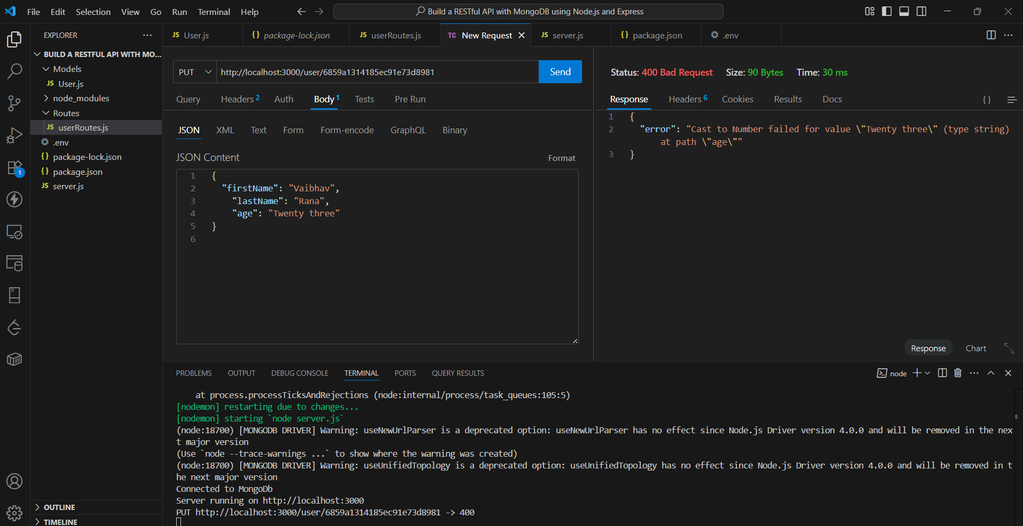

**4. Unknown field in request (e.g., food)**

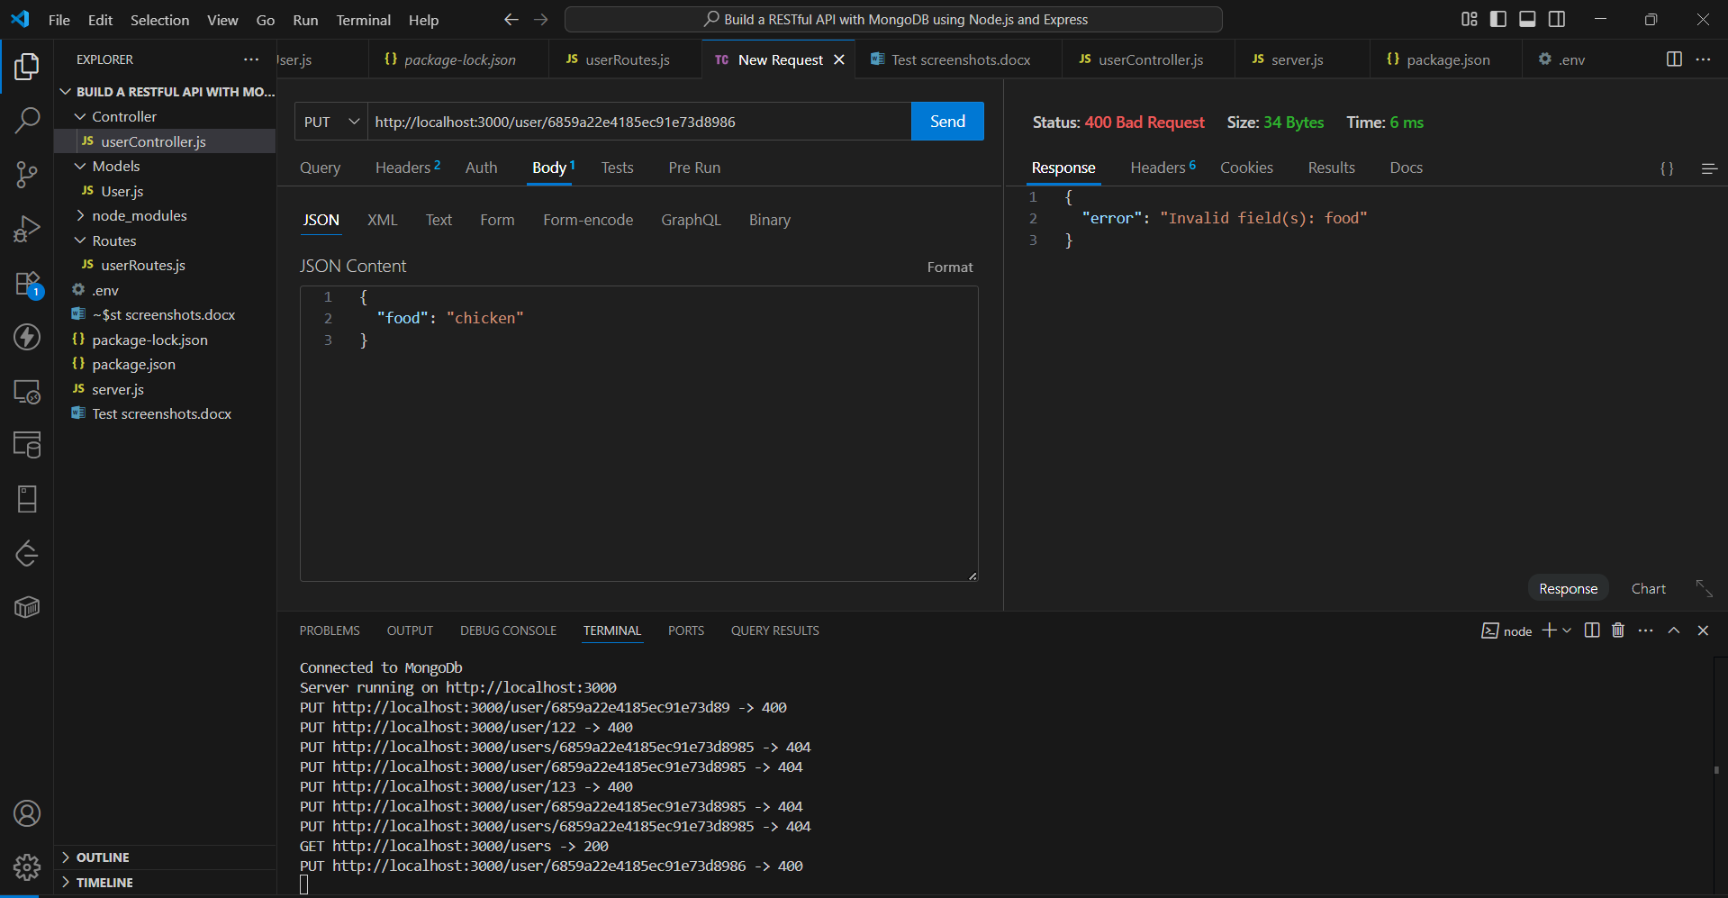

**5. DELETE: Remove a User**

**Success**

DELETE /user/665fcabc3aa1b3a1d74907f3

**Response:**

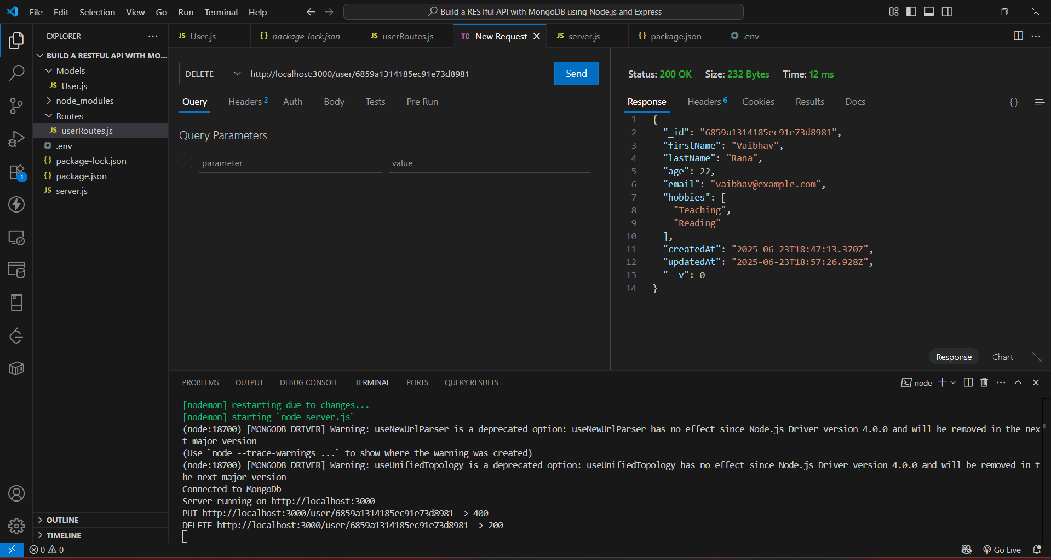

**Error 1: Invalid ID format**

DELETE /user/abc

**Response:**

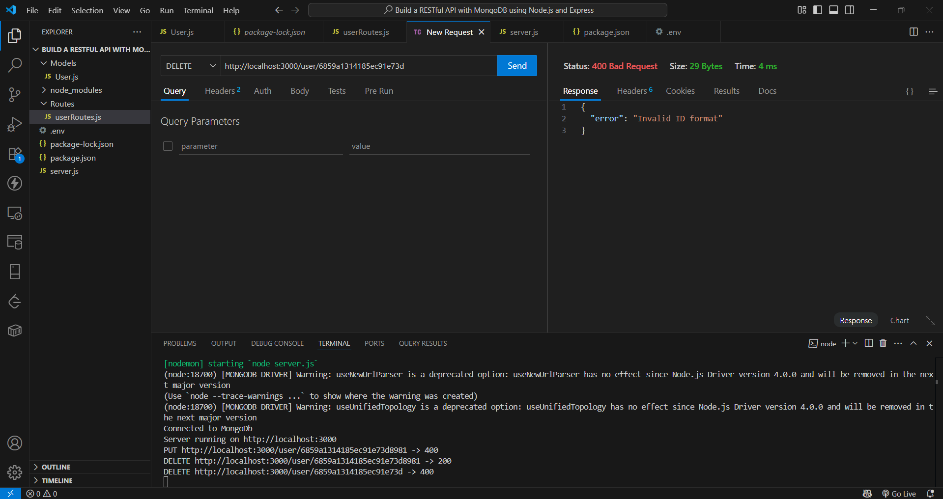

**Error 2: Not found**

DELETE /user/665fcabc3aa1b3a1d7490000

**Response:**

